# 1



Sirve para ver el estado de una rutina en cada instante de tiempo, el valor de las variables, punteros, subrutinas, etc por que no se me ocurre nada mas

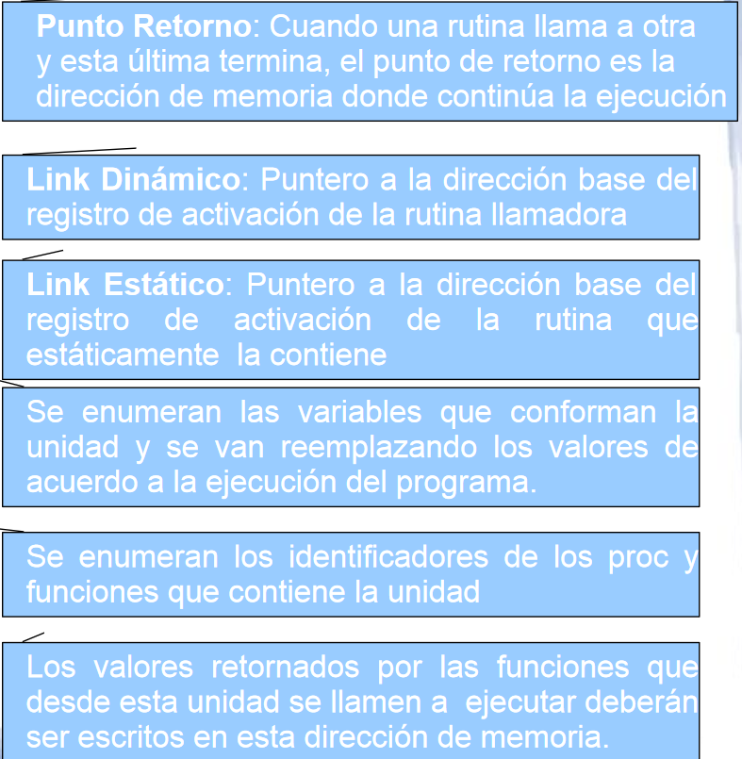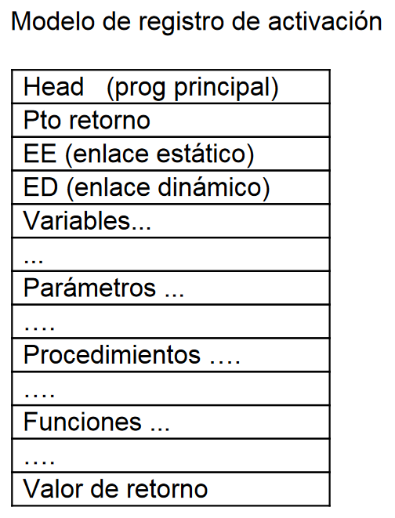

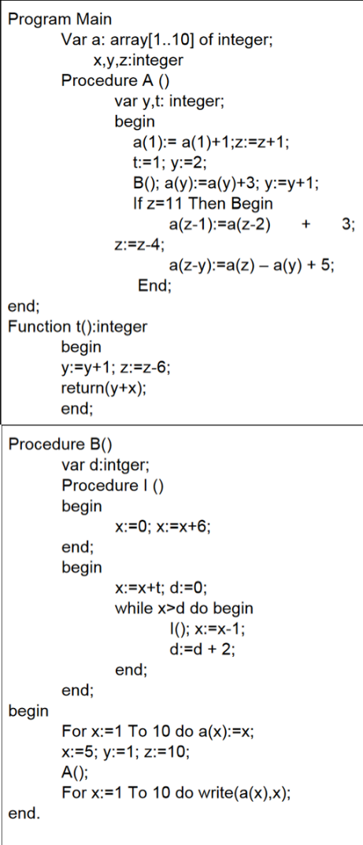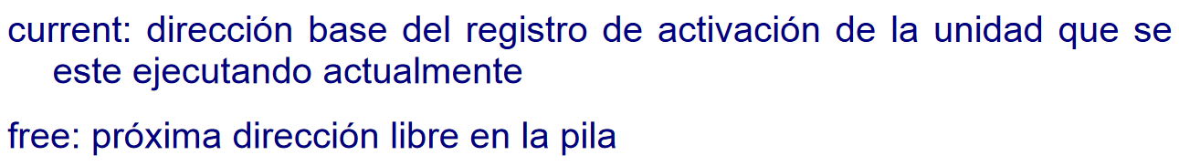

# 2.

|  |  |
| --- | --- |
|  | Registro de activación main |
| *1 | Pto retorno |
|  | EE |
|  | ED |
|  | A(1)=~~1~~ 2 |
|  | A(2)=~~2~~ 5 |
|  | A(3)=3 |
|  | A(4)=4 |
|  | A(5)=5 |
|  | A(6)=6 |
|  | A(7)=7 |
|  | A(8)=8 |
|  | A(9)=9 |
|  | A(10)=10 |
|  | X= ~~1..10~~ ~~5~~ ~~13 0 6 5 0 6 5 0 6 5~~  1..10 |
|  | Y= ~~1~~ -~~2~~ 3 |
|  | Z= ~~10~~ ~~11~~ 5 |
|  | Procedure A |
|  | Function T |
|  | Procedure B |
|  | VR |

imprime: 2 1

imprime: 5 2

imprime: 3 3

imprime: 4 4

imprime: 5 5

imprime: 6 6

imprime: 7 7

imprime: 8 8

imprime: 9 9

imprime: 10 10

|  |  |
| --- | --- |
| *2 | Reg Activ A |
|  | Pto Retorno *1 |
|  | EE (*1) |
|  | ED (*1) |
|  | Y = ~~2~~ 3 |
|  | T = 1 |
|  | VR |

|  |  |
| --- | --- |
| *3 | Reg Act B |
|  | Pto Retorno *2 |
|  | EE *1 |
|  | ED *2 |
|  | D = ~~0 2 4~~ 6 |
|  | Procedure | |
|  | VR 8 |

|  |  |
| --- | --- |
| *4 | Rec Act t |
|  | Pto Retorno *3 |
|  | EE *1 |
|  | ED *3 |
|  | VR |

|  |  |
| --- | --- |
| *5 | Rec Act | |
|  | Pto Retorno *3 |
|  | EE *3 |
|  | ED *3 |
|  | VR |
|  |  |
| *6 | Rec Act | |
|  | Pto Retorno *3 |
|  | EE *3 |
|  | ED *3 |
|  | VR |
| *7 | Rec Act | |
|  | Pto Retorno *3 |
|  | EE *3 |
|  | ED *3 |
|  | VR |

## Cadena dinámica

|  |  |
| --- | --- |
|  | Registro de activación main |
| *1 | Pto retorno |
|  | A(1)=~~1 2~~ 5 |
|  | A(2)=2 |
|  | A(3)=~~3~~ 6 |
|  | A(4)=4 |
|  | A(5)=5 |
|  | A(6)=6 |
|  | A(7)=7 |
|  | A(8)=8 |
|  | A(9)=9 |
|  | A(10)=10 |
|  | X= ~~1..10~~ ~~5~~ ~~13 0 6 5 0 6 5 0 6~~ ~~5~~ 1..10 |
|  | Y= ~~1~~ 2 |
|  | Z= ~~10~~ ~~11~~ 5 |
|  | Procedure A |
|  | Function T |
|  | Procedure B |
|  | VR |



imprime: 5 1

imprime: 2 2

imprime: 6 3

imprime: 4 4

imprime: 5 5

imprime: 6 6

imprime: 7 7

imprime: 8 8

imprime: 9 9

imprime: 10 10

|  |  |
| --- | --- |
| *2 | Reg Activ A |
|  | Pto Retorno *1 |
|  | EE (*1) |
|  | ED (*1) |
|  | Y = ~~2~~ ~~3~~ 4 |
|  | T = 1 |
|  | VR |

|  |  |
| --- | --- |
| *3 | Reg Act B |
|  | Pto Retorno *2 |
|  | EE *1 |
|  | ED *2 |
|  | D =~~0 2 4~~ 6 |
|  | Procedure | |
|  | VR 8 |

|  |  |
| --- | --- |
| *4 | Reg Act t |
|  | Pto Retorno *3 |
|  | EE *1 |
|  | ED *3 |
|  | VR |

|  |  |
| --- | --- |
| *5 | Reg Act | |
|  | Pto Retorno *3 |
|  | EE *3 |
|  | ED *3 |
|  | VR |
| *6 | Reg Act | |
|  | Pto Retorno *3 |
|  | EE *3 |
|  | ED *3 |
|  | VR |
| *7 | Reg Act | |
|  | Pto Retorno *3 |
|  | EE *3 |
|  | ED *3 |
|  | VR |

# 3

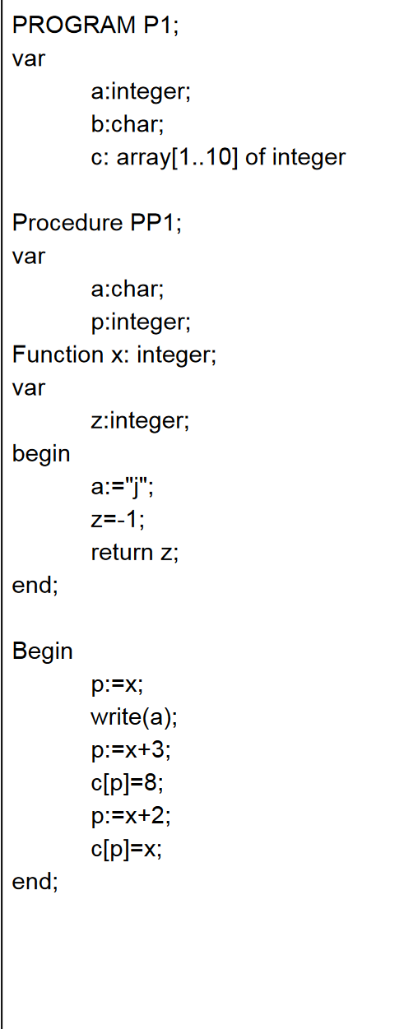 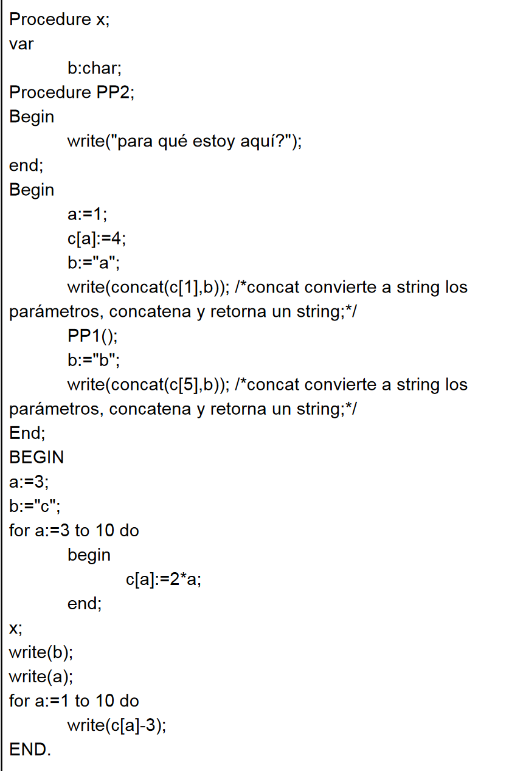

P1

PP1 x

x pp2

## Estatico

|  |  |
| --- | --- |
| * n | Registro de activación |
|  | Pto retorno |
|  | EE |
|  | ED |
|  | VR |

|  |  |
| --- | --- |
| * 1 | Registro de activación P1 |
|  | Pto retorno |
|  | EE |
|  | ED |
|  | a = ~~3 3..10 1~~ 1..10 |
|  | b = “c” |
|  | c(1) = ~~4~~ -1 |
|  | c(2) = 8 |
|  | c(3) = 6 |
|  | c(4) = 8 |
|  | c(5) = 10 |
|  | c(6) = 12 |
|  | c(7) = 14 |
|  | c(8) = 16 |
|  | c(9) = 18 |
|  | c(10) = 20 |
|  | Procedure PP1 |
|  | Procedure X |
|  | VR |

imprime: “c”

imprime: “1”

imprime: -4

imprime: 5

imprime: 3

imprime: 5

imprime: 7

imprime: 9

imprime: 11

imprime: 13

imprime: 15

imprime: 17

|  |  |
| --- | --- |
| * 2 | Registro de activación X |
|  | Pto retorno *1 |
|  | EE *1 |
|  | ED *1 |
|  | b = ~~“a”~~ “b” |
|  | VR |

Imprime : 4a

Imprime : 10b

|  |  |
| --- | --- |
| * 3 | Registro de activación PP1 |
|  | Pto retorno *2 |
|  | EE *1 |
|  | ED *2 |
|  | Function x |
|  | a = ~~“j” “j”“j”~~ “j” |
|  | p = ~~-1~~ ~~2~~ 1 |
|  | VR ~~-1 -1~~ ~~-1~~ -1 |

imprime “j”

|  |  |
| --- | --- |
| * 4 | Registro de activación PP1 func x |
|  | Pto retorno *3 |
|  | EE *3 |
|  | ED *3 |
|  | Z = -1 |
|  | VR |

|  |  |
| --- | --- |
| * 5 | Registro de activación PP1 func x |
|  | Pto retorno *3 |
|  | EE *3 |
|  | ED *3 |
|  | Z = -1 |
|  | VR |

|  |  |
| --- | --- |
| * 6 | Registro de activación PP1 func x |
|  | Pto retorno *3 |
|  | EE *3 |
|  | ED *3 |
|  | Z = -1 |
|  | VR |

|  |  |
| --- | --- |
| * 7 | Registro de activación PP1 func x |
|  | Pto retorno *3 |
|  | EE *3 |
|  | ED *3 |
|  | Z = -1 |
|  | VR |

## Dinámico (CREO QUE QUEDA IGUAL)

# 4

Estático

|  |  |
| --- | --- |
| * n | Registro de activación |
|  | Pto retorno |
|  | EE |
|  | ED |
|  | VR |

|  |  |
| --- | --- |
| * 1 | Registro de activación Main |
|  | Pto retorno |
|  | EE |
|  | ED |
|  | y = ~~7~~ 9 |
|  | x = ~~1..7~~ ~~3~~ ~~2~~ ~~5 2 7~~ 4 ~~2~~  2 |
|  | vec(1) = ~~1~~ ~~2~~ 2 |
|  | vec(2) = ~~2~~ ~~8~~ 10 |
|  | vec(3) = 3 |
|  | vec(4) = ~~4~~ ~~11~~ 4 |
|  | vec(5) = ~~5~~ 30 |
|  | vec(6) = 6 |
|  | vec(7) =7 |
|  | Function B |
|  | Procedure D |
|  | Procedure C |
|  | VR |

Y= B (esto dio 2) + 5

vec(2):= 8 + x = 8+2

vec(5):= vec(2) * 3 = 10*3=30

imprime 2,10,3,4,30,6,7

|  |  |
| --- | --- |
| * 2 | Registro de activación B |
|  | Pto retorno *1 |
|  | EE *1 |
|  | ED *1 |
|  | y = 4 |
|  | VR = 2 |

x = 4-2 (esto se cambia en Main)

|  |  |
| --- | --- |
| * 3 | Registro de activación D |
|  | Pto retorno *1 |
|  | EE *1 |
|  | ED *1 |
|  | i = ~~2~~ 4 |
|  | x = ~~1..7~~ 1 |
|  | vec(1) = 1 |
|  | vec(2) = 2 |
|  | vec(3) = 3 |
|  | vec(4) = ~~4~~ |
|  | vec(5) = 5 |
|  | vec(6) = 6 |
|  | vec(7) = 7 |
|  | Procedure A |
|  | Function B |

Imprime 1,2,3,4,5,6,7

|  |  |
| --- | --- |
| * 4 | Registro de activación PA de D |
|  | Pto retorno *3 |
|  | EE *3 |
|  | ED *3 |
|  | y = 7 |
|  | VR |

Y= 2 + 5

Se calcula ( Vec(i+2):= vec(i+2)+y = vec(4):= 4 + 7 )

Se calcula (x = x + B ) = 2+3 = 5

Llama a C

|  |  |
| --- | --- |
| * 5 | Registro de activación PD func B |
|  | Pto retorno *4 |
|  | EE *3 |
|  | ED *4 |
|  | Z = -1 |
|  | VR 3 |

Vec(i) – vec(1) = vec(4)-1= 3

Se calcula vec(i):= y + 2 = vec(2):= 7 + 2

Se calcula i:= i + 2

Se calcula vec(i):= vec(1) * i = vec(4):= 1 * 4

|  |  |
| --- | --- |
| * 6 | Registro de activación C |
|  | Pto retorno *4 |
|  | EE *1 |
|  | ED * 4 |
|  | i = ~~1~~ 4 7 |
|  | y = ~~6~~ 2 |
|  | VR |

Se calcula x = x + B(el *7) = 5 + 2 = 7

Se calcula vec(2) := vec(2) * 4 = vec(2):= 2 * 4 = 8

Entra al while:

-Calcula vec(1):= vec(1) + B(*8) -1 = vec(1):= 1 + 2 -1 = 2

I := i + 3

-Calcula vec(1):= vec(1) + B(*9) -1 = vec(1):= 1 + 2 -1 = 2

I := i + 3

Termina loop

|  |  |
| --- | --- |
| * 7 | Registro de activación B |
|  | Pto retorno *6 |
|  | EE *1 |
|  | ED *6 |
|  | y = 4 |
|  | VR = 2 |

x = y – 2 = 2

|  |  |
| --- | --- |
| * 8 | Registro de activación B |
|  | Pto retorno *6 |
|  | EE *1 |
|  | ED *6 |
|  | y = 4 |
|  | VR = 2 |

x = y – 2 = 2

Dinámico

|  |  |
| --- | --- |
| * n | Registro de activación |
|  | Pto retorno |
|  | EE |
|  | ED |
|  | VR |

|  |  |
| --- | --- |
| * 1 | Registro de activación Main |
|  | Pto retorno |
|  | EE |
|  | ED |
|  | y = 7 |
|  | x = ~~1..7~~ 3 |
|  | vec(1) = 1 |
|  | vec(2) = 2 |
|  | vec(3) = 3 |
|  | vec(4) = ~~4~~ |
|  | vec(5) = 5 |
|  | vec(6) = 6 |
|  | vec(7) =7 |
|  | Function B |
|  | Procedure D |
|  | Procedure C |
|  | VR |

Y= B (esto dio 2) + 5

vec(2):= 8 + x = 8+2

vec(5):= vec(2) * 3 = 10*3=30

imprime 2,10,3,4,30,6,7

|  |  |
| --- | --- |
| * 2 | Registro de activación B |
|  | Pto retorno *1 |
|  | EE *1 |
|  | ED *1 |
|  | y = 4 |
|  | VR = 2 |

x = 4-2 (esto se cambia en Main)

|  |  |
| --- | --- |
| * 3 | Registro de activación D |
|  | Pto retorno *1 |
|  | EE *1 |
|  | ED *1 |
|  | i = ~~2~~ 4 |
|  | x = ~~1..7~~ ~~1~~ ~~5~~ ~~2~~ 7 |
|  | vec(1) = 1 |
|  | vec(2) = ~~2~~ ~~8~~ 56 |
|  | vec(3) = 3 |
|  | vec(4) = ~~4~~ ~~10~~ 4 |
|  | vec(5) = 5 |
|  | vec(6) = 6 |
|  | vec(7) = 7 |
|  | Procedure A |
|  | Function B |

Imprime 1,2,3,4,5,6,7

|  |  |
| --- | --- |
| * 4 | Registro de activación PA de D |
|  | Pto retorno *3 |
|  | EE *3 |
|  | ED *3 |
|  | y = 6 |
|  | VR |

Y= 1 + 5

Se calcula vec(i+2):= vec(i+2)+y = vec(4):= 4 + 6

Se calcula (x = x + B ) = 2+3 = 5

Llama a C

|  |  |
| --- | --- |
| * 5 | Registro de activación PD func B |
|  | Pto retorno *4 |
|  | EE *3 |
|  | ED *4 |
|  | Z = -1 |
|  | VR 3 |

Vec(i) – vec(1) = vec(4)-1= 3

Se calcula vec(i):= y + 2 = vec(2):= 6 + 2

Se calcula i:= i + 2

Se calcula vec(i):= vec(1) * i = vec(4):= 1 * 4

|  |  |
| --- | --- |
| * 6 | Registro de activación C |
|  | Pto retorno *4 |
|  | EE *1 |
|  | ED * 4 |
|  | i = ~~1~~ 4 7 |
|  | y = ~~6~~ 2 |
|  | VR |

Se calcula x = x + B(el *7) = 5 + 2 = 7

Se calcula vec(2) := vec(2) * 4 = vec(2):= 8 * 7 = 56

Entra al while:

-Calcula vec(1):= vec(1) + B(*8) -1 = vec(1):= 1 + 2 -1 = 2

I := i + 3

-Calcula vec(1):= vec(1) + B(*9) -1 = vec(1):= 1 + 2 -1 = 2

I := i + 3

Termina loop

|  |  |
| --- | --- |
| * 7 | Registro de activación B |
|  | Pto retorno *6 |
|  | EE *1 |
|  | ED *6 |
|  | y = 4 |
|  | VR = 2 |

x = y – 2 = 2

|  |  |
| --- | --- |
| * 8 | Registro de activación B |
|  | Pto retorno *6 |
|  | EE *1 |
|  | ED *6 |
|  | y = 4 |
|  | VR = 2 |

x = y – 2 = 2